Introduction

The Open Wobble Switch is a force-activated assistive switch that is activated by moving a wand in any direction. It can be activated using several different body parts including the hand, temple, chin, and tongue (through cheek).

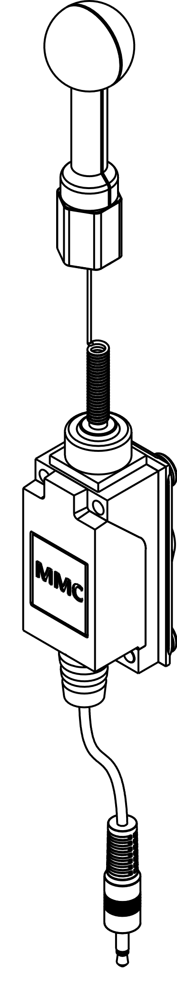Features

Topper Top

Topper Base

Switch Body

Mounting Adapter

Mono Cable

Specification

|  |  |
| --- | --- |
| Size | L: 240 mm x W: 30 mm x T: 35 mm |
| Activation Force | ~0.55 N (55 gf) |
| Cleaning | Damp Cloth |
| Disinfection | Ethyl Alcohol, Isopropyl Alcohol, Hydrogen Peroxide |

Mounting the Switch

The Wobble Switch has a mounting adapter with a female ¼”- 20 UNC thread, so it can be attached to a variety of camera and other assistive mounting solutions.

Connecting the Switch

1. Connect the 3.5 mm cable from the switch to the assistive device.

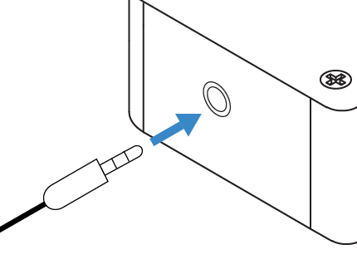

# Activating the Switch

1. Activate the switch by applying force onto the wand.

# Swapping Topper Tops

1. Remove the existing Topper Top by holding the Topper Top and Topper Base and unscrewing the threads.
2. Attach the new Topper Top by holding the Topper Base and screwing in the threads.